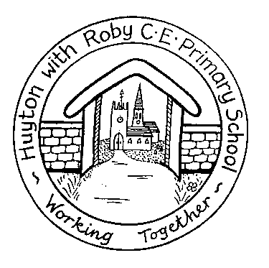

Reading
Information

Key Stage 1 (Years 1 to 2)
Key Stage 2 (Year 3)

Dear Parents/ Carers
At Huyton with Roby C.E. Primary School we aim to foster a love of reading and ensure your child learns to read well. Numerous research projects have found that the more a child reads the better reader they will be. As quoted in the Independent:
'Reading is like swimming. Getting a 10 metre swimming certificate is not the end of your swimming career. It is the beginning. Once you can propel yourself forward, you can build up stamina and enjoy the water. You could swim the Channel or participate in the Olympics. But not if you hardly ever go in the water!'
To become a good reader, children need to read regularly. Any reading is a positive experience, especially when it is exciting and has purpose. Your child will receive a scheme and library book from school and the local library is also a good resource for you to use with your child. You can model good reading to your child by talking about what and why you read yourself, so that they can appreciate reading as a lifelong skill, as well as taking it in turns to read a sentence, page or paragraph.
Having the opportunity to re-read known, familiar books is important for the development of fluency which is a critical component of excellent reading.
Reading a familiar book allows your child to practise reading with expression, at a conversational pace and with enjoyment. Reading fluently and smoothly is essential as it makes the meaning of the text much clearer and this helps children understand what they are reading. Children enjoy frequently returning to their favourite books and benefit greatly from re-reading a book.
There are many genres of reading that the children will be exposed to. These include: fiction, information books, poetry, plays, autobiographies, biographies, classic novels, mysteries, short stories and fables.

Your child will receive a different reading record book from those used in previous years. We are trying to encourage our children to read every day. This could be a small amount or as much as they would like to read.
In your child’s new reading record book there is a weekly diary. Please add comments from yourself or your child each day.
Your child will read to a teacher or teaching assistant once a week and they will comment in your child’s reading record book once a week. They will be given 2 books every week. If your child requires more books please do not hesitate to ask your child’s class teacher and they will provide you with more books.
We would like your child to record their favourite story every week. This could be a story they have read in school, at home or it could be one of their reading books from school.
You will find a section ‘Books I have read’. Please encourage your child to write the books they have read and record whether they liked the book or not.

Home Reading
Below are a few suggestions for ways in which you can support your child's reading development at home:
• Talk about the pictures and discuss what they notice and how this relates to the text. There are amazing picture books for all ages.
• Encourage your child to listen to themselves reading and monitor how accurate it sounds and whether it makes sense.
• Share a story by reading alternate lines, paragraphs or pages with your child. This modelling is vital to their development.
• Draw your child’s attention to features of the text such as paragraphs, chapters and punctuation marks.
• Practise reading and spelling some words that appear in the text. You can do this through simple games, such as making words with magnetic letters or challenging them to create as many words as they can from another word, i.e. “How many words can you make from elephant?”
• Check your child understands the meaning of new words. We are aware that sometimes young readers read quite complex words easily but without understanding their meaning.
• Discuss any exciting words that the author has used and why this helps to make the text more interesting.
• Encourage your child’s to attempt to work out any tricky or unknown words and support them in using strategies such as self-correction
• Ask your child if they can predict what the book will be about as they look at the cover and title. As they read, ask them if they can predict what might happen next.
• When you have completed a book ask your child what they have enjoyed about the text and share your own views.
We hope you will find this information helpful. Please do not hesitate to ask if you have any queries.
HAPPY READING!

